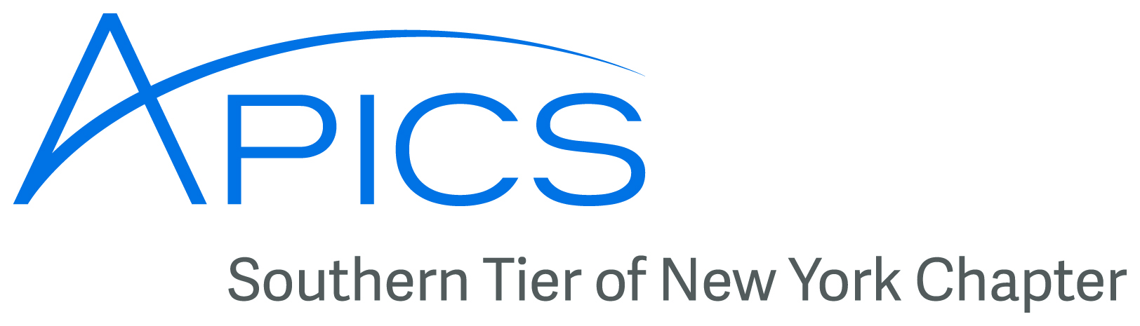
www.stapics.org

NO DINNER MEETING THIS MONTH

C-BAR Award

The more chronologically challenged among us will remember the vinyl record, and its tendency to skip. Well, imagine a record that skipped, saying, “The Southern Tier of New York chapter of APICS has won Silver Level for C-BAR. The Southern Tier of New York chapter of APICS has won Silver Level for C-BAR. The Southern Tier of New York chapter of APICS has won Silver Level for C-BAR. “

For we have done it now for the 4th (or is it 5th? ) year in a row!

To refresh your memories, C-BAR is APICS’s way of measuring its chapters and channel partners. This ensures that we, your chapter board of directors, use your APICS membership dues wisely. We have to show that we provide education, outreach, and other benefits to our members, and that we don’t take your dues and send ourselves off to Bimini.

If you have any questions about C-BAR (or anything else APICS), please contact any member of the Board.

APICS Update from Don Sheldon, Director of Education

CPIM – Unfortunately we did not have enough interest to continue the CPIM series at BCC. We did have a small but successful first module (Basics of Supply Chain Management) in the summer. We will reconsider this series is there is interest. If you are interested in any other Southern Tier offerings, please contact me at dsheldon@sheldoninc.com. Thanks!

APICS Student Competition in Albany – Our area has not had representation at the popular and growing APICS college student supply chain competition but this is about to change. This year we will start a new trend. I have agreed to coach a student team from Binghamton University. The generous Board of Directors from the APICS Southern Tier Chapter of New York have agreed to sponsor the BU team, paying all of the team’s expenses. We have already started meeting on campus and the students are even getting college credit for participating.

The teams can be 3 or 4 students and the winners in Albany (first weekend in February) win prizes and a chance to compete at the APICS conference, which in 2014 will be in New Orleans. Watch for more information and come to support your local team from Binghamton University in February.

Thanks!
Don Sheldon

APICS CSCP

Fail your CSCP exam? Don’t panic! You can try again for free (limited time only)! APICS is pleased to announce a promotion for APICS CSCP candidates designed to increase testing confidence—and save cost. From now until the end of 2013, candidates who take the APICS CSCP for the first time and do not pass are eligible for one retake exam at no cost. This offer is being extended to first-time
candidates who do not pass the APICS CSCP exam sometime between September 21, 2013, and the end of 2013.

Qualified retake candidates need to contact APICS at cscpexam@apics.org to take advantage of this limited-time offer. Qualified retake candidates will receive an exam credit that must be used within one year of date issued.

As a reminder, we are offering these upcoming APICS CSCP exam windows in North America:
November 30, 2013–January 11, 2014

How do I request lifetime certification?

Did you know that at age 62, your certification becomes permanent?!

Lifetime certification is available to individuals who are at least 62 years of age and have current (non-suspended) certifications. Individuals with suspended or expired certifications must bring their certifications current before applying for lifetime certification. To request lifetime certification, submit your request to the APICS Certification department in writing along with a copy of a government-issued ID which confirms your age (drivers license, passport, etc). Requests can be mailed to APICS HQ (Attn: Lifetime Certification), faxed to +1 773 639-3171, or emailed to certification@apics.org


FALL BACK
Sunday, November 3

Thursday, November 27

Board of Directors 2013-2014

President

Dave Gardner, CPIM

dgardner@emtmetals.com

Executive VP /Director of Finance

Steve Whited

steven.whited@acco.com

Secretary

Debbie Unkel, CPIM

deb.unkel@raymondcorp.com

Director of Membership/Director of Chapter Standards/ Director of Online Publication

Lee Schechter , CPIM

lschechter@stny.rr.com

Director of Programming and Marketing

Michael LoSapio

Michael.LoSapio@SynergyResources.net

Director of Publicity

Kelly Norieka

Kelly.norieka@lmco.com

2nd Director of Publicity

Chris Reinwald

creinwald@gmail.com

Director of Education

Don Sheldon, CPIM, CIRM, CSCP

dsheldon@sheldoninc.com

Director at Large

Steve Stanchak, CPIM

steve.stanchak@infoprint.com

Director of Student Relations

Brian Arrnold

barnold@amphenol-aao.com

2nd Director of Student Relations

Don Sheldon, CPIM, CIRM, CSCP

dsheldon@sheldoninc.com

Director of Communications

April McWeeney, CPIM

april.mcweeney@acco.com

Southern Tier APICS
PO Box 1107
Binghamton NY 13902-1107

